Evadale Water Control and Improvement District No. 1
TO: THE BOARD OF DIRECTORS OF EVADALE WATER CONTROL AND IMPROVEMENT DISTRICT NO. 1 AND TO ALL OTHER INTERESTED PERSONS:
NOTICE OF POSTPONEMENT

The Regular scheduled Board Meeting that was scheduled for Monday, November 27, 2023 has been postponed until Thursday, November 30, 2023 due to lack of quorum.

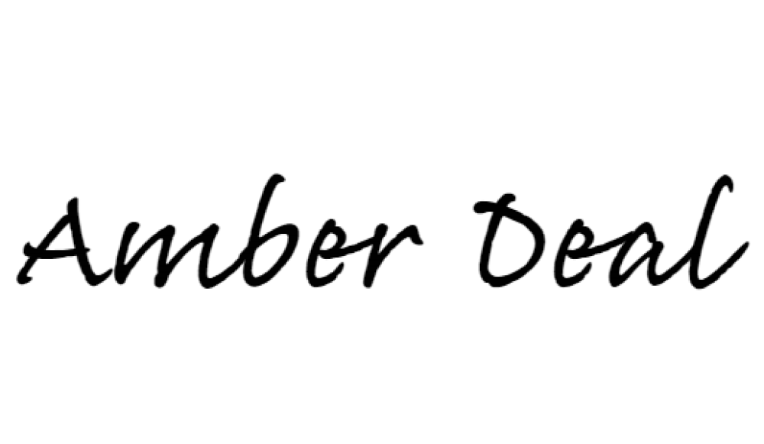
_______________________________________
Amber Deal
District Manager
EWCID #1

