Evadale Water Control and Improvement District No. 1
TO: THE BOARD OF DIRECTORS OF EVADALE WATER CONTROL AND IMPROVEMENT DISTRICT NO. 1 AND TO ALL OTHER INTERESTED PERSONS:
NOTICE OF POSTPONEMENT

The Regular scheduled Board Meeting that was scheduled for Monday, June 26, 2023 has been postponed until Thursday, June 29, 2023 due to lack of a quorum available.

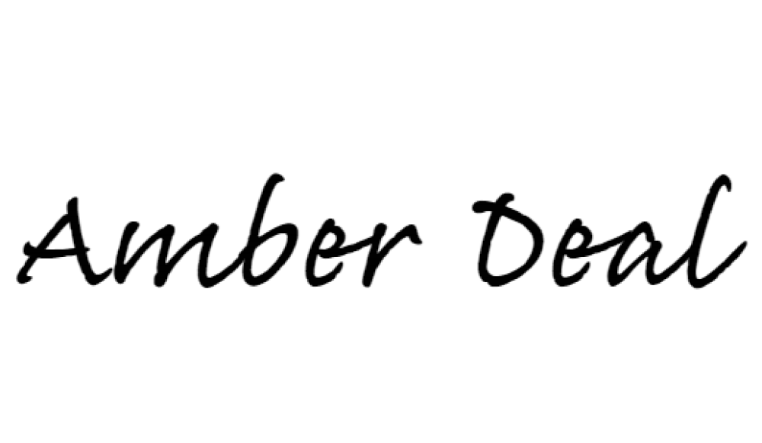
_______________________________________
Amber Deal
District Manager
EWCID #1

